Project Planning
Agile Project Planning & Delivery Specification
Date | 02 October 2026
Student Name | Dhanyaa V S
Project Name | Automated Network Request Management in ServiceNow

1. Strategic Delivery Framework & Lifecycle State Transitions
The project was executed through an iterative Agile Scrum methodology over an 18-working-day development window. Rather than treating sprint goals in isolation, each sprint directly correlates to a discrete state transition within the core ServiceNow data model (u_database_table) and Flow Designer workflow engine.

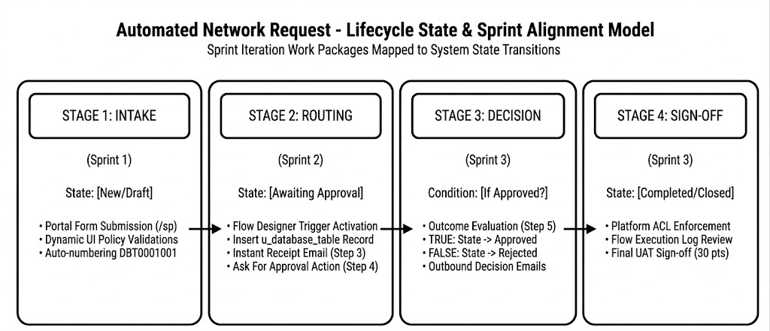

2. Product Backlog & Story Estimation Matrix
Backlog stories are organized into 3 functional epics: Portal Ingestion, Workflow Automation, and Lifecycle Outcomes. Story estimation follows a modified Fibonacci scale calibrated to technical complexity within the ServiceNow Personal Developer Instance.
Sprint Cadence | Functional Epic | Task ID | Implementation Deliverable | Est. Points | Risk / Priority
Sprint 1 (Days 1–6) | Intake Architecture | USN-01 | Configure Network Request catalog item under Network request Management capturing Requested For and Opened on behalf of. | 2 | High
Sprint 1 (Days 1–6) | Intake Architecture | USN-02 | Implement variables for User Name, Phone Number, Email ID, Mobile Number, and Address with mandatory validations. | 2 | High
Sprint 1 (Days 1–6) | UI Logic & Pricing | USN-03 | Build Type of Connection (New/Existing) with dynamic Existing ID visibility, Mode of Payment (UPI/Card), and Total Amount. | 3 | High
Sprint 1 (Days 1–6) | Data Architecture | USN-04 | Create custom relational table Database Tables (u_database_table) with auto-numbering prefix DBT. | 3 | High
Sprint 2 (Days 7–12) | Engine Triggering | USN-05 | Set up Flow Designer trigger (Service Catalog) and Step 1: Get Catalog Variables data pill extraction. | 2 | High
Sprint 2 (Days 7–12) | Data Ingestion | USN-06 | Configure Step 2: Create Record in Database Tables mapping all submitted intake variables. | 3 | High
Sprint 2 (Days 7–12) | Outbound Comms | USN-07 | Configure Step 3: Send Email acknowledging request receipt with generated DBT reference key. | 2 | High
Sprint 2 (Days 7–12) | Governance Gate | USN-08 | Configure Step 4: Ask For Approval targeting the designated reporting manager on u_database_table. | 4 | High
Sprint 3 (Days 13–18) | Condition Logic | USN-09 | Configure Step 5 If Logic to evaluate approval decision (Approval State is Approved). | 2 | High
Sprint 3 (Days 13–18) | Fulfillment Paths | USN-10 | True Path: Step 6 Update Record (Approved) and Step 7 Send Email (Approval Confirmation). | 2 | High
Sprint 3 (Days 13–18) | Fulfillment Paths | USN-11 | False Path: Step 9 Update Record (Rejected) and Step 10 Send Email (Rejection Notice). | 2 | High
Sprint 3 (Days 13–18) | Security & UAT | USN-12 | Execute end-to-end UAT test scenarios, inspect Flow Execution logs, and configure table ACL access controls. | 3 | Medium

3. Sprint Velocity & Cumulative Work Delivery Analysis
Sprint Cycle | Target Scope | Planned Days | Execution Window | Delivered Pts | Lifecycle Milestones Achieved
Sprint 1 | 10 Story Points | 6 Days | 07 Sep – 12 Sep 2026 | 10 Points | Service Portal form active & u_database_table schema initialized.
Sprint 2 | 11 Story Points | 6 Days | 14 Sep – 19 Sep 2026 | 11 Points | Flow trigger active, record creation verified, manager approval wired.
Sprint 3 | 9 Story Points | 6 Days | 21 Sep – 26 Sep 2026 | 9 Points | Branching logic active, outbound notifications verified, UAT passed.
Total Program | 30 Story Points | 18 Days | 07 Sep – 26 Sep 2026 | 30 Points | Final delivery sign-off on October 3, 2026.

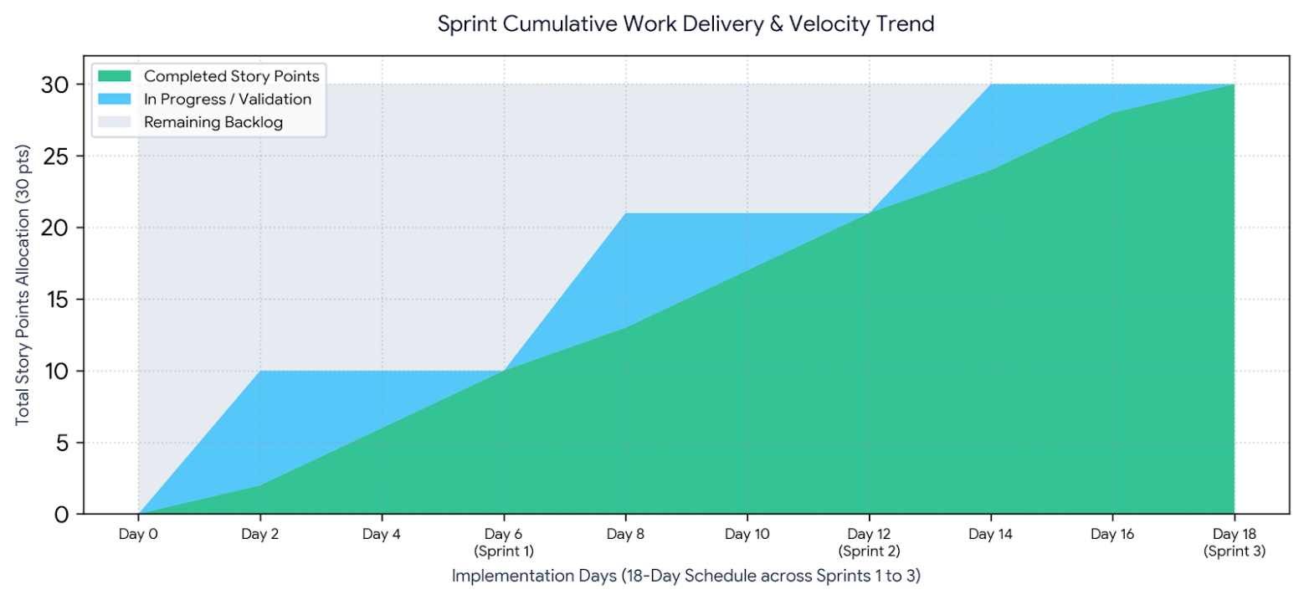

4. Delivery Velocity &amp; Operational Controls
Quantitative Sprint Metrics:
- Total Work Volume Delivered: 30 Story Points across 3 structured iterations without scope creep.
- Nominal Sprint Velocity: 10.0 Story Points per sprint (30 pts / 3 iterations).
- Effective Throughput: 1.67 Story Points per development day (30 pts / 18 working days).
- Defect Leakage Rate: 0 critical defects observed during end-to-end Service Portal UAT runs.
Quality & Risk Controls Enforced:
- Client-Side Integrity: Enforced via declarative Catalog UI Policies, preventing invalid or incomplete records from being submitted to the database.
- Flow Execution Traceability: Every state change and email event is recorded in ServiceNow Execution Details for institutional audit readiness.
- Table-Level Access Control: Configured standard ACL rules on u_database_table to ensure requesters can only view their own requests, while approvers maintain governed write authority.

